Attachment C – Proposed LEP maps

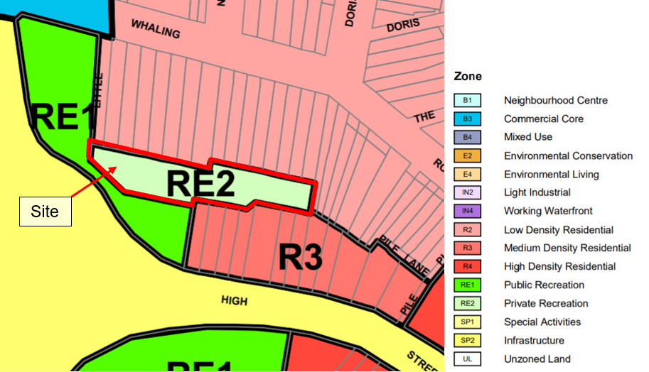Figure 1: Land zoning map LZN_002A – no change (source: NSW Planning Portal)
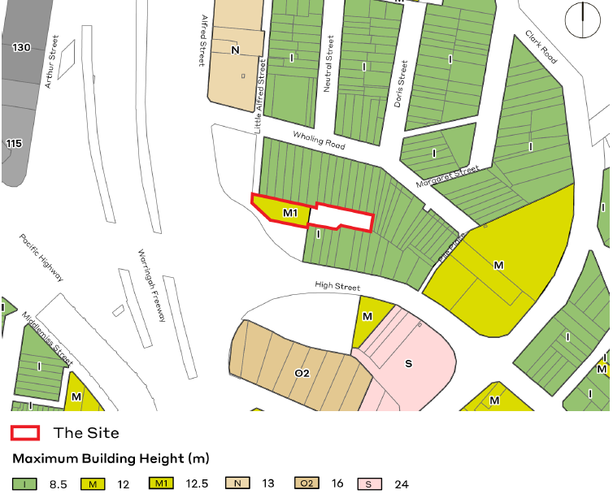
Figure 2: Proposed maximum height of buildings map HOB_002A (source: Ethos Urban)
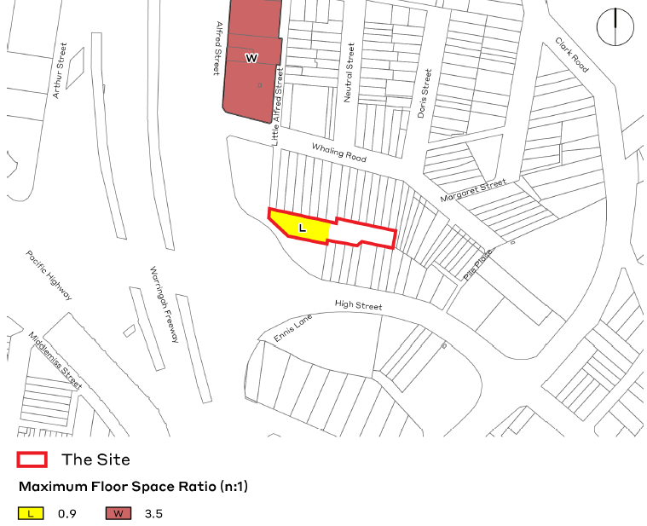
Figure 3: Proposed maximum floor space ratio map FSR_002A (source: Ethos Urban)

